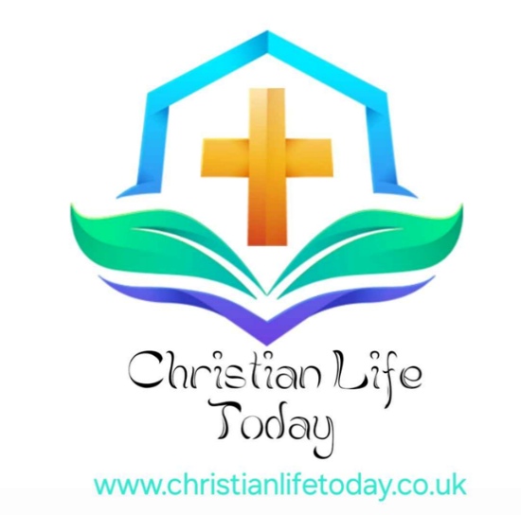
What Is Christian Faith?
Introduction
The Christian faith is centered on a relationship with God through His Son, Jesus Christ. It’s more than a religion—it’s a way of life, based on love, grace, and truth.
Core Beliefs of Christianity
God
Christians believe in one God who exists in three persons: Father, Son (Jesus Christ), and Holy Spirit. God is the Creator of all things and desires a personal relationship with every person.
God’s Nature
Christians believe in one God who eternally exists in three Persons: Father, Son (Jesus Christ), and Holy Spirit (the Trinity).
Jesus Christ
Central to Christianity is Jesus is the Son of God who came to earth, lived a sinless life, died on the cross, and rose again. Through His life, death, and resurrection, He offers forgiveness, salvation, and eternal life to all who believe in Him.
The Bible
The Bible is God’s Word and the foundation for Christian belief and practice. It reveals who God is, His love for humanity, and His plan of redemption. The Bible (Old and New Testaments) is regarded as God’s inspired Word and the ultimate guide for faith and life.
Salvation by Grace
Salvation is a gift from God. It’s not earned by good deeds but received by faith in Jesus Christ. Through His grace, believers are forgiven and made new. People are reconciled to God not by their own efforts but by grace through faith in Jesus Christ (Ephesians 2:8–9).
Holy Spirit
The Spirit indwells believers, empowering them to live godly lives, understand Scripture, and serve others.
Hope of Eternal Life
Christians look forward to Christ’s return, resurrection of the dead, final judgment, and the restoration of all things in a new creation.
Living the Faith
Christianity isn’t just about belief—it’s about transformation. Christians are called to follow Jesus, love others, serve, and live with hope, purpose, and integrity.
Why the Christian Faith Matters?
In a world full of questions, the Christian faith offers hope, peace, and a solid foundation. It answers life’s biggest questions: Who am I? Why am I here? What happens after I die?
© This website is subject to copyright and belongs to Christian Life Today. If you would like to reuse any of the materials, please contact first via the contact page, thank you.

© This document is subject to copyright and belongs to Christian Life Today. If you would like to reuse any of the materials, please contact first via the contact page, thank you.

