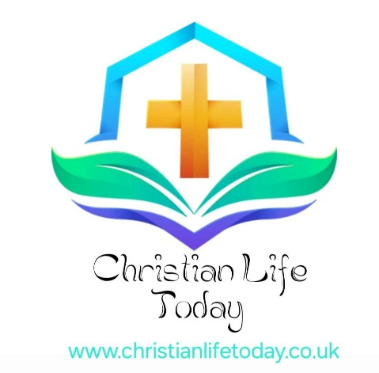

Bridging The Generation Gap
One Body, Many Generations – Growing Together in Christ
“One generation shall commend your works to another, and shall declare your mighty acts.”
— Psalm 145:4 (ESV)

Introduction: The Beauty of Generational Diversity
In a world often divided by age, preferences, and cultural trends, the Church stands as a unique space where generations are not meant to compete, but to complete one another. While society may cater to age-specific groups—targeting the young with trends and technology, or the older with tradition and legacy—the Kingdom of God invites every generation into one unified family.
The local church is not merely a gathering place for like-minded people of the same era. It is the family of God—a beautiful, diverse community of believers from all walks of life and every age. From newborn babies to wise elders, every person has a role to play, a voice to share, and a testimony to give.

God’s Plan for Generational Unity
Throughout Scripture, God reveals His heart for generational partnership. He is the God of Abraham, Isaac, and Jacob—a covenantal God who blesses through lineage, legacy, and shared faith.
“Tell to the coming generation the glorious deeds of the Lord, and his might, and the wonders that he has done.”
— Psalm 78:4
In the Bible, older generations are called to teach, guide, and bless. Younger generations are called to listen, honour, and carry forward the faith. This is not a one-way street but a sacred exchange—a spiritual dialogue between the seasoned and the emerging.
The prophet Joel declared a day when the Spirit would be poured out on all flesh—sons and daughters would prophesy, old men would dream dreams, and young men would see visions (Joel 2:28). This paints a glorious picture of intergenerational revival. Unity across age is not optional; it is God-ordained.

The Generation Gap: A Modern Challenge
In modern times, the term "generation gap" refers to the cultural, emotional, and technological differences between younger and older people. The gap may be seen in:
- Worship styles: hymns vs. contemporary praise.
- Communication: handwritten letters vs. social media and texting
- Church engagement: traditional roles vs. innovative ministry
- Worldview and values: shaped by different historical experiences.
These differences, while real, do not have to divide. The Church must choose unity over uniformity, and love over personal preference.
“Be completely humble and gentle; be patient, bearing with one another in love. Make every effort to keep the unity of the Spirit through the bond of peace.”
— Ephesians 4:2–3

Biblical Models of Intergenerational Relationship
Scripture gives us many examples of how generations can walk together in faith:
- Moses and Joshua – Moses mentored Joshua, preparing him to lead the Israelites into the Promised Land (Deuteronomy 31:7–8).
- Naomi and Ruth – Naomi’s wisdom and Ruth’s loyalty created a redemptive lineage that would eventually lead to the birth of King David (Ruth 1–4).
- Eli and Samuel – Though imperfect, Eli guided young Samuel to hear God’s voice (1 Samuel 3).
- Paul and Timothy – Paul calls Timothy his “true son in the faith,” modelling discipleship and spiritual fathering (1 Timothy 1:2).
These relationships were not transactional—they were transformational. They reflected trust, humility, openness, and spiritual maturity from both sides.

Why the Church Needs Every Generation
Each generation brings a God-given strength:

The Older Generation Offers:
- Wisdom from life experience
- Spiritual maturity and knowledge of God’s Word
- Testimonies of God’s faithfulness
- Guidance for younger believers
- Stability and prayer covering for the Church
“Gray hair is a crown of splendor; it is attained in the way of righteousness.”
— Proverbs 16:31

The Younger Generation Offers:
- Fresh passion and energy for ministry
- New ideas and creativity for outreach
- Zeal for change and revival
- Technological fluency to reach modern culture
- Availability for service and learning
“Let no one despise you for your youth, but set the believers an example in speech, in conduct, in love, in faith, in purity.”
— 1 Timothy 4:12

Healing the Divide: Practical Steps for Bridging the Gap
- Create spaces for mutual learning.
Host intergenerational Bible studies or prayer groups where younger and older believers can share and learn from one another.
- Encourage mentorship.
Pair older Christians with younger ones for regular fellowship, discipleship, and encouragement.
- Foster inclusive worship.
Blend traditional and contemporary styles to reflect the full Body of Christ, allowing different generations to feel represented.
- Celebrate testimonies across ages.
Share stories of God’s work through seniors, youth, and children alike.
- Be willing to listen.
Listening is a form of love. Encourage open dialogue between age groups within your church community.
- Pray for unity.
Ask God to break down generational pride, assumptions, and barriers.

Devotional Reflection: Together, We Are Whole
When we walk side by side—elders and youth, mentors and learners—we reflect the completeness of the Church as Christ intended. The Body of Christ is not fully alive when generations are separated or at odds. But when we honour one another, value each other's voice, and work together for the Gospel, we embody the Kingdom on earth.
In heaven, there will be no generational gap—only eternal praise, side by side.
“From the lips of children and infants you, Lord, have called forth your praise.”
— Matthew 21:16
“Even to your old age and gray hairs I am he, I am he who will sustain you.”
— Isaiah 46:4

Prayer: Uniting Generations in Christ
Heavenly Father,
Thank You for the richness of generational diversity within Your Church. We thank You for elders who carry Your wisdom, and for the youth who carry Your fire. Heal any divisions caused by misunderstanding or pride. Teach us to love and serve one another with joy. Make our churches places where every generation belongs and flourishes. May we pass the baton of faith faithfully from one hand to the next until Christ returns. In Jesus’ name, amen.

Join the Movement: Build the Bridge
🌟 Are you a senior with wisdom to share?
🌟 Are you a young believer looking for guidance?
🌟 Is your church ready to embrace all generations in love and mission?
Christian Life Today invites you to be part of a movement that honours every age and strengthens the Church for generations to come.
📩 Share your own story of how God bridged the gap in your life:
Contact Us christianlifetoday.co.uk/contact/
Together, let’s build a Church where generations walk as one—learning, loving, and living for Christ.
© This website is subject to copyright and belongs to Christian Life Today. If you would like to reuse any of the materials, please contact first via the contact page, thank you.

